**Project Design Phase-II**

**Data Flow Diagram & User Stories**

|  |  |
| --- | --- |
| Date | 30 October 2022 |
| Team ID | PNT2022TMID06083 |
| Project Name | Project - IOT based safety gadget for child safety monitoring and notification |
| Maximum Marks | 4 Marks |

**Data Flow Diagrams:**

A Data Flow Diagram (DFD) is a traditional visual representation of the information flows within a system. A neat and clear DFD can depict the right amount of the system requirement graphically. It shows how data enters and leaves the system, what changes the information, and where data is stored.

**Flow Diagram**

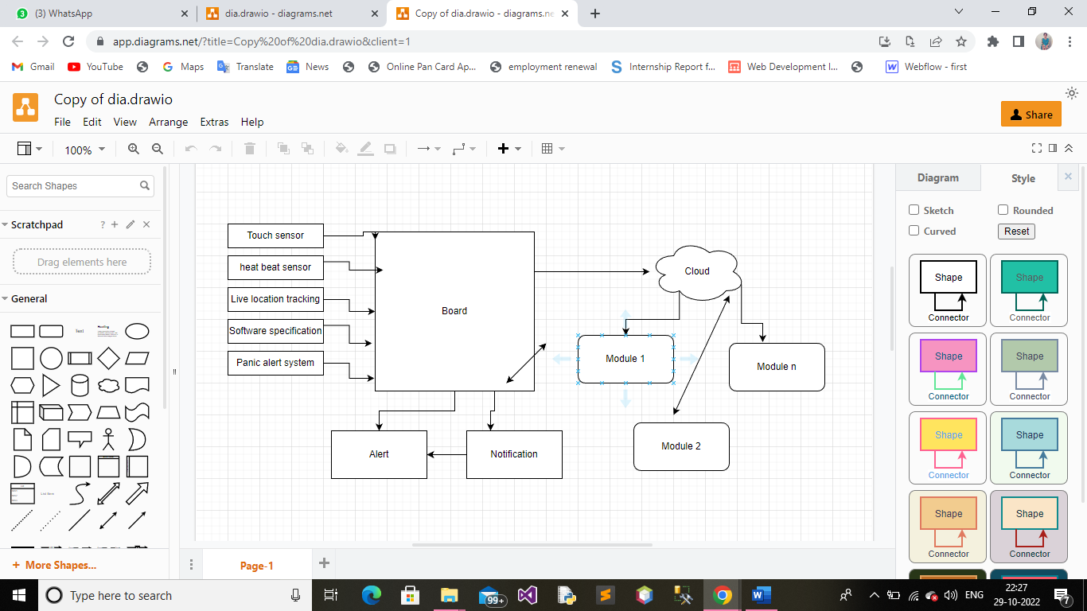

**User Stories**

Use the below template to list all the user stories for the product.

| **User Type** | **Functional Requirement (Epic)** | **User Story Number** | **User Story / Task** | **Acceptance criteria** | **Priority** | **Release** |
| --- | --- | --- | --- | --- | --- | --- |
| Customer (Mobile user) | Live location tracking | USN-1 | Safety gadget contains a GPS module, fetch the current location | I can receive a notification | Medium | Sprint-1 |
|  | Panic alert system | USN-2 | It consists of a button that is triggered only during certain panic situation. |  | High | Sprint-1 |
|  | Stey Connected system | USN-3 | To communicate between safety gadget and parental phone always connected irrespective of the situation. | I can receive a alaram | High | Sprint-2 |
|  | Health monitoring system | USN-4 | The gadget consists of heart beat and temperature sensor which is used to monitor the general health condition of child. |  | Medium | Sprint-1 |
|  | Gadget plug and Unplug monitoring | USN-5 | This feature is to keep monitoring if the safety gadget is plugged or not by monitoring the contact switch. |  | High | Sprint-1 |
|  | Boundary monitoring system | USN-6 | Binding gadget is the device which is used to satisfy this feature along with the safety gadget and parental phone. |  |  |  |
|  |  |  |  |  |  |  |
| Customer Care Executive |  |  | Doesn’t need to memorize the specific keywords to send. |  |  |  |
| Administrator |  |  | The current value of sensors can be monitor via app. |  |  |  |
|  |  |  |  |  |  |  |
|  |  |  |  |  |  |  |
|  |  |  |  |  |  |  |